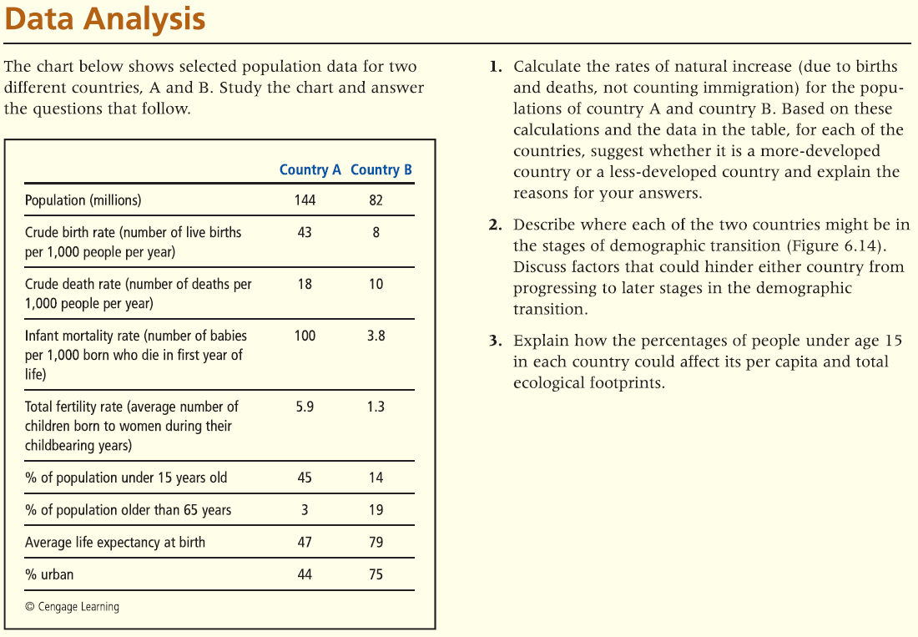Answer the following 3 questions. There is no word count limit, as long as you answer the question. The more concise the better.

# Questions

**1. Calculate the rates of natural increase (due to births and deaths, not counting immigration) for the population of country A and country B. Based on these calculations and the data in the table, for each of the countries, suggest whether it is a more-developed country or a less-developed country and explain the reasons for your answers.**

The rate is calculated subtracting crude birth and crude death, so the results are:

A: 43 - 18 = 25  
B: 8 - 10 = -2  
A is a less-developed country because it has a fertility rate equal to 5.9.In the other hand, B is a more-developed country because its fertility rate is 1.3,

**2. Describe where each of the two countries may be in the stages of demographic transition. Discuss factors that could hinder either country from progressing to later stage is in the demographic transition.**

Based in the chart, Country A might be at the second stage of demographic transition, the transitional stage, because the birth rate are more that death. Country B is at the fourth rate, the postindustrial stage, because its birth rate is lower than the death rate.

**Explain how the percentages of people under 15 years of age in each country could affect its per capita and total ecological footprints.**

A country with a large percentage of its people younger age 15 will increase its population very fast. Because of this case, the number of births in this country will be increase for serveral year, might decades.